# Intro

## CAES

(Center for Advanced Energy Systems)

The Center for Advanced Energy Systems (CAES) is a multidisciplinary center dedicated to the creation, development, and promotion of new technologies and practices in the field of energy systems. The center's mission includes the dissemination of knowledge through education and technology transfer, and providing leadership in shaping present and future of energy policy in the state and nation. This 'full service' center has activities in research, education and outreach seeking to increase visibility, awareness, and impact within the state as well as addressing problems of significant national interest.

## About

**The Center for Advanced Energy Systems (CAES)** is a multidisciplinary center dedicated to the creation, development, and promotion of new technologies and practices in the field of energy systems. The center's mission includes the dissemination of knowledge through education and technology transfer, and providing leadership in shaping present and future of energy policy in the state and nation. This "full service" center has activities in research, education and outreach seeking to increase visibility, awareness, and impact within the state as well as addressing problems of significant national interest.

Faculty associated with the center come from the Departments of Industrial and Systems Engineering, Mechanical and Aerospace Engineering, Electrical and Computer Engineering, Chemical and Biochemical Engineering Department, and Civil and Environmental Engineering; The Rutgers Center for Operations Research and the Bloustein School of Planning and Public Policy.

The Center also has a significant impact on students, both in engineering and other related fields. Energy systems are of interest to many engineering disciplines including Chemical, Electrical, Industrial, Mechanical and Materials Science. Other departments within Rutgers currently working in energy systems include environmental science, public policy, the business school and RUTCOR.

# Research

## Oscillating Fluidized Bed Combustion

**Motivation:** particles in fluidized beds can agglomerate for a number of reasons (electrical, chemical, mechanical interactions) and decrease the effectiveness of heat and mass transfer throughout the bed. External oscillations can help these up, but effects on other aspects of fluidization are unknown

**Approach:** a fluidized bed system has been developed with external oscillation for small particle fluidized beds. Oscillating the bed externally reduces bed height. Work continues to understand why this bed height reduction occurs including the addition of fines and comparing round particles with ground particles.

**Fundamental Issues:** models of oscillating fluidized beds with round monodisperse particles do not show the bed collapse seen in the lab.

## Grid Fault Tolerant CHP

**Motivation:** most small scale power systems are not designed to operate in grid fault situations which is both surprising and dangerous in terms of industrial productivity.

**Approach:** develop protocols for new and retrofit systems which will allow grid fault tolerance for inside the fence (load shedding protocols) and outside the fence (large system turndown) installations

**Fundamental Issues:** there is little known about both short term and long term operation of small scale power systems with significant turndown. Issues involve operation of the turbine or engine itself and problems such as localized condensation in steam systems

## Optimizing Industrial Desiccation

**Motivation:** the use of desiccants to dry air using waste heat is becoming very popular. It is both energy efficient and a valuable use of low grade waste heat especially during the summertime. None of the current devices, with either wheels or towers, use any feedback loops to optimize performance

**Approach:** a laboratory test stand has been developed to observe and optimize the performance of desiccant wheels using newly developed temperature and relative humidity sensors to both learn details about the adsorption processes and determine the potential benefits of developing "smart" systems.

**Fundamental Issues:** success requires modeling of adsorption and absorption processes in unsteady flows

## Potential of Environmental Dispatching

**Motivation:** with a very large number of power plants contributing to the daily electrical power consumption of a power pool, and the need to reduce emissions of greenhouse gasses signal the need to change how choices are made in selecting different power sources to supply the grid

**Approach:** Analyze the PJM power pool using their data and information from EPA's eGrid software to determine the emissions reductions possible if power plants were dispatched entirely associated with the environmental profile and not economics

**Fundamental Issues:** data available does not consider changes in a power plants performance when operating off peak. This is critical information need to take the next step.

## New Steam Engine Applications

**Motivation:** steam power is still very important, but there are some applications where steam turbines are not well suited and use of steam engines is indicated

**Approach:** a review of current steam engine designs and performance is underway to allow for a reasoned assessment of their role in small scale power.

**Fundamental Issues:** new rotary designs and compact heat exchangers open up a new range of power system parameters. This is asking new questions about materials, fuels, and cycle design

## The Vortex Tube: Novel Applications

**Motivation:** vortex tubes generate energy separation through a valve-like device. Used historically as a spot cooling device, there are several areas where waste pressure exists which are excellent potential applications for vortex tubes

**Approach:** several areas of under study including using vortex tubes as in geothermal re-boilers, in desalination systems, and in flash economizers on chillers

**Fundamental Issues:** many of the features of vortex tubes are unexplained, leading to design by trial and error additional understanding will allow better modeling and design.

## The Vortex Tube: Role of the Generator

**Motivation:** the distribution of flow between hot and cold sides is controlled by a tapered valve on the hot side and an orifice on the cold side and little is known about their individual roles in flow and energy separation

**Approach:** Several generators were made with different outlet orifice diameters and explored the interdependence of inlet pressure, cold fraction and orifice diameter with the performance of the vortex tube

**Fundamental Issues:** If the ratio of flow is maintained, what happens to the energy separation as the diameter of the generator changes size?

## The Vortex Tube: Scaling up to Industrial

**Motivation:** it is important to know how large a vortex tube can be made. Energy separation requires a matching of length scales for compressibility, turbulence and vortices.

**Approach:** develop a vortex tube with continuously variable internal diameters using cones and disks. Use flow visualization and energy separation measurements to determine maximum tube diameters

**Fundamental Issues:** There is no clear understanding of length scales associated with the competing phenomena

## The Vortex Tube: Two Phase Flow

**Motivation:** With large energy separation comes condensation in the cold tube. However, location of droplet formation is delayed in the core flow because of lack of nucleating sites. Many questions arise from either trying to promote or delay the appearance of droplets.

**Approach:** Using large pressure drops and large diameters generators, small wire probes are to be inserted into the cold exhaust to promote condensation.

**Fundamental Issues:** many questions about the none equilibrium thermodynamics of the exhausting flow require understanding including time and length scales.

# Courses taught by CAES Faculty

## Alternative Energy Systems: 650:474

-Taught by: [Dr. Kimberly Cook-Chennault](https://caes.rutgers.edu/people)

***Summary:***

Critical analysis of use of wasted energy; design parameters that influence the performance of wind, geothermal, solar, fuel cells, and biomass alternative energy systems; and the challenges associated with incorporation of these systems into the United States current infrastructure.

## Power Plants 650:462

-Taught by: [Dr. Michael R. Muller](https://caes.rutgers.edu/people)

***Summary:***

Current theory and practice of cycles and design of equipment for the generation of power in central stations and industrial power plants. Design projects.

View Heat Transfer Course Info Page (unavailable)

# CAES Services

## Assessments

* An onsite comprehensive review of all plant systems
* Includes waste and productivity review.
* Recommends energy projects with implementation costs, savings and paybacks

### (Details)

**Assessments:**

The industrial energy assessment is a one day onsite review of all plant systems, culminating in a report with recommended annual energy cost savings measures. The assessment focuses on areas of significant savings opportunities, favoring measures such as process heat recovery over lighting upgrades. Rutgers CAES has extensive experience conducting assessments as well overseeing them from its management of the Industrial Assessment Centers program (IAC). Assessments teams are comprised of experienced staff engineers, graduate and undergraduate students. The assessment process itself can be broken down into three parts: the pre-assessment information gathering phase, the one day plant assessment and the final report.

**Pre-assessment:**

Prior to the onsite visit, the team at CAES learns as much as possible about the facility in order to generate ideas that can be discussed and investigated the day of the assessment. Analyzing the current energy usage of the plant allows the team to identify possible areas of excess consumption as well as perform a cost analysis to insure accuracy in our recommendations. The team at Rutgers CAES will analyze each plant system the day of the plant visit. For example, whether the facility uses natural gas or electric furnaces can make a huge difference in savings opportunities.information about what type of equipment employed at the facility has a great impact on the types of recommendations made. In order to be as accurate in our recommendations as possible, we usually ask that companies fill out as much info as they can on our pre-assessment forms and that they supply 12 months of energy bills.

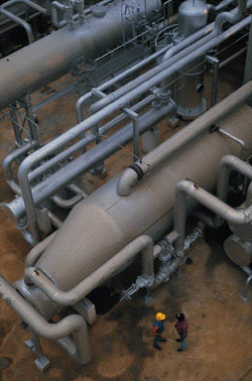

**Assessment Day Breakdown:**

The day of the assessment begins with meeting the plant management and personnel. The plant process and operations with their related equipment are discussed, along with any concerns that pant management, engineers or maintenance personnel might have about energy systems in the plant. Ideas that the team has brainstormed from the pre-assessment information are run by plant personnel, and if deemed worth looking into by are investigated during the plant tour. After the initial meeting, the team then tours the plant. Ideas and concerns brought up in the initial meeting are explored in the plant tour, and measurements are taken using portable equipment where necessary. More detailed measurements over time can also be taken with data loggers that can be mailed back to CAES, such as compressor load over the workday. After the plant walkthrough, the CAES team sits down with plant management again to discuss any new ideas and findings from the tour.

**Assessment Report:**

After the assessment is concluded, the CAES team uses the data collected to compile a report with energy saving recommendations. Each recommendation has estimated annual energy and cost savings, implementation costs, payback period and rebate information. The calculations are shown in case the future energy costs change from the supplied billing information. Recommendations typically have a payback of 2-3 years. Other measures that are considered are also included in the report. These are ideas we had, but the financial feasibility wasn't there or we did not have enough resources to give an accurate calculation. Useful information for energy conservation is also included.

Contact us for more information: [contact page](http://caes.rutgers.edu/contact)

## Vendor Proposal Reviews

* Protects plant management from over-priced vendor proposals
* A check of the engineering calculations & assumptions, as well as the labor and equipment costs.
* Can determine if the vendor proposal was custom made or 'boiler plate', or if the proposed system is oversized.

### (Details)

Vendors often provide engineering services as part of their installation. Many times, work billed as custom engineering work is actually a 'boiler plate' type proposal used multiple times before, and â€œtweakedâ€ for your plant. As a result, checking the engineering calculations of a vendor proposal for technical accuracy is crucial to ensuring a projectâ€™s viability. Reviewing these calculations can reveal performance killing issues such as improper sizing of equipment, overly conservative rules of thumb or incorrect engineering assumptions made. A poorly designed system can result in annual savings being much lower than expected, greatly increasing the payback period. Similarly, factors such as available rebates, warranty coverage, as well as recurring operation and maintenance costs all have an effect on the total cost of your project. Making sure these factors are accounted for is a critical component in keeping a project's cost low.

Rutgers CAES can provide a technical review where we check the vendor proposals for large projects. The vendor proposal review will provide a breakdown of all costs, and check these against industry average costs. The expected annual savings and payback period will be included as well, along with all supporting calculations. Whether it is consideration of a solar array, a combined heat and power system or HVAC ice storage, we can help you make the best choice in purchasing equipment for your company.

Contact us for more information: [contact page](http://caes.rutgers.edu/contact)

## Energy Awareness Training

* Energy usage and cost analysis reviewed with plant management.
* Comparison of facility's specific consumption to other similar plants.
* Demonstration of how energy efficiency measures that have been implemented in other similar plants can improve the plant's energy costs.

### (details)

How does your plant's energy use compare to the industry? Rutgers CAES can provide an overall energy analysis of your plant and give a comparison of your baseline usage to other similar plants. The analysis would be from 12 months of energy bills, and would look at each month as well as the aggregate usage. Factoring in the type and size of manufacturing facility, a comparison can be made to similar plants.

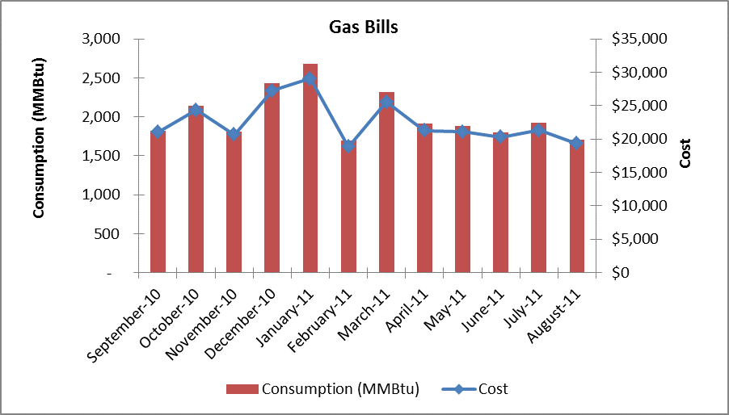

As part of the energy awareness training, a review of energy efficiency measures that similar plants have successfully implemented is also included. The average savings and costs of these recommendations are examined, as well as the recommended next steps to have these options investigated.

Contact us for more information: [contact page](http://caes.rutgers.edu/contact)

## Certification Mentorship

* Energy Management Systems (EnMS) designate an energy management team to continually improve energy efficiency and reduce annual costs.
* EnMS provide a selection of 'shovel ready' projects for when funding becomes available.
* Certifications such as ISO 50001 and SEP have their own requirements and rule-sets, and Rutgers CAES can mentor companies through the certification process.

### (details)

CAES Services

**Certification Mentorship**

Certified energy management systems such as ISO 50001 and Superior Energy Performance (SEP) provide companies the means to continuously reduce energy usage. Energy Management Systems (EnMS) establish a team to track and reduce energy usage, by providing a stream of "shovel ready" projects to improve energy performance. Each certification has its own metrics, rules and requirements, but share the following characteristics:

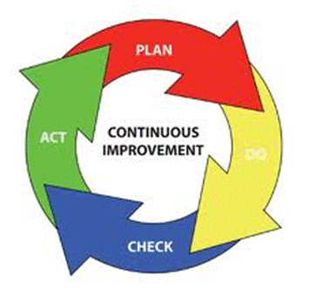

* An energy policy in which top management makes an official statement of the organization's commitment to managing energy.
* A cross-divisional management team led by a representative who reports directly to management and is responsible for overseeing the implementation of the energy management system.
* Energy reviews to assess current and planned energy use, energy sources, and consumption and identify opportunities for improvement.
* Baseline of the organization's energy use.
* Energy performance indicators (EnPIs) that are unique to the company and are tracked to measure progress.
* Energy objectives and targets for energy performance improvement at relevant functions, levels, processes or facilities within an organization.
* Action plans to meet those targets and objectives.
* Operating controls and procedures for significant energy uses.
* Measurement, management, and documentation for continuous improvement for energy efficiency.
* Internal audit of progress to management based on these measurements.

Contact us for more information: [contact page](http://caes.rutgers.edu/contact)

## Smart Metering & Equipment Efficiency Monitoring

* Using small, portable smart meters, we can see the exact energy profile of your equipment over the course of the workday.
* Smart meters can also measure productivity by monitoring process equipment loads.
* We can then determine the areas when the operation

### (details)

**Smart Metering & Equipment Efficiency Monitoring**

With traditional billing, you only get an overall view of a plant's energy consumption over a monthly period. You may know or have an idea which equipment uses the most energy, but without any detailed data it is impossible to tell what your equipment's behavior at startup, operation and idle is really like. A smart meter is a small portable device that monitors and logs power consumption over time, with many meters recording power data in the sub-second range. Placing smart meters on specific pieces of equipment provides concrete data from which often times surprising solutions can be drawn. For example, without a smart meter it is impossible to determine whether the current draw at startup of a motor would negate the benefits of shutting down idling equipment. In a recent case study we performed, we found that the start-up current draw did not affect average demand, and it was worth it to shut the idling equipment off. Smart meters can also be used as a diagnostic tool. Older equipment may seem to be operating as good as new, but without hard data it is impossible to tell. Monitoring equipment power consumption over the workday using a smart meter may show that it is performing inefficiently. This can allow plant management to repair or replace equipment as necessary, and avoid any excessive energy costs.

See how smart metering allowed Swepco to save on idling costs in our recent [case study.](http://njiep.rutgers.edu/swepco_njiep.pdf)

Rutgers CAES can provide a Smart Metering & Equipment Efficiency monitoring service, where we measure your equipment's energy consumption over the course of the workday. As part of this service, you will receive a detailed report analyzing your equipment's energy profile with suggested measures on how to save energy. The analysis will include a summary of how much your equipment's current annual energy cost is, as well as how much estimated annual energy cost savings can be realized by enacting each suggested measure.

Contact us for more information: [contact page](http://caes.rutgers.edu/contact)

## Smart Metering & Equipment Efficiency Monitoring

* Using small, portable smart meters, we can see the exact energy profile of your equipment over the course of the workday.
* Smart meters can also measure productivity by monitoring process equipment loads.
* We can then determine the areas when the operation is the least efficient and suggest measures to remedy excess consumption.

### (details)

**Smart Metering & Equipment Efficiency Monitoring**

With traditional billing, you only get an overall view of a plant's energy consumption over a monthly period. You may know or have an idea which equipment uses the most energy, but without any detailed data it is impossible to tell what your equipment's behavior at startup, operation and idle is really like. A smart meter is a small portable device that monitors and logs power consumption over time, with many meters recording power data in the sub-second range. Placing smart meters on specific pieces of equipment provides concrete data from which often times surprising solutions can be drawn. For example, without a smart meter it is impossible to determine whether the current draw at startup of a motor would negate the benefits of shutting down idling equipment. In a recent case study we performed, we found that the start-up current draw did not affect average demand, and it was worth it to shut the idling equipment off. Smart meters can also be used as a diagnostic tool. Older equipment may seem to be operating as good as new, but without hard data it is impossible to tell. Monitoring equipment power consumption over the workday using a smart meter may show that it is performing inefficiently. This can allow plant management to repair or replace equipment as necessary, and avoid any excessive energy costs.

See how smart metering allowed Swepco to save on idling costs in our recent [case study.](http://njiep.rutgers.edu/swepco_njiep.pdf)

Rutgers CAES can provide a Smart Metering & Equipment Efficiency monitoring service, where we measure your equipment's energy consumption over the course of the workday. As part of this service, you will receive a detailed report analyzing your equipment's energy profile with suggested measures on how to save energy. The analysis will include a summary of how much your equipment's current annual energy cost is, as well as how much estimated annual energy cost savings can be realized by enacting each suggested measure.

Contact us for more information: [contact page](http://caes.rutgers.edu/contact)

## Clean Technology and Power Site Evaluation

We can determine your site's suitability for many types of clean technologies:

* Combined heat & power
* Simple onsite power using opportunity fuels
* Renewables (mostly solar and wind) Ground source heat pumps

Thermal Energy Storage

### (detail)

**Clean Technology and Power Site Evaluation**

Many clean technologies are on the market that can provide significant savings for a facility. Onsite power generation can provide significant savings in addition to providing a hedge against future energy costs. Solar, wind and other renewables can provide clean electricity. Combined heat and power (CHP) systems can provide power as well as usable heat for processes or space conditioning. For facilities with excess waste products, power generation from waste fuels can be an option worth investigating. Other technologies can reduce HVAC costs significantly, such as thermal storage (ice storage) or ground source heat pump systems. No matter what option is investigated, the evaluation consists of a technical and a financial analysis detailed in a report. The report will detail every calculation, as well as summarize the analysis with bottom line figures including the annual energy cost savings that can be realized, the estimated implementation costs and simple payback period.

**Technical Analysis**

The estimated annual energy savings are calculated in the technical analysis portion of the report. All calculations will be included and explained in the report, which differ depending on the technology being evaluated.

**Financial Analysis**

The estimated implementation cost and other costs are taken into account in the financial analysis portion of the report. Estimated equipment, installation, maintenance costs are calculated based on the system and site characteristics. Any rebates or credits that can lower the costs are also taken into account, and information on how to qualify for them is also included. The annual energy cost savings are also calculated and used to determine the simple payback period of the system. Other metrics are also included, such as cost per kilowatt for solar panels.

## Demand Response Evaluation

Power companies offer incentives to large users to reduce their load, usually as a credit per kW reduced from the base load. Rutgers CAES can provide an evaluation of:

* The feasibility of implementing a demand response program.
* The current effectiveness of a demand response program.

Learn more about demand response evaluations [here.](http://caes.rutgers.edu/demand)

### (Detail)

**Demand Response Evaluation**

Power companies offer incentives to large users to reduce their load during peak demand, which occurs from noon to 8 PM during summer weekdays. The facility tries to reduce the load to a target agreed upon with the power company, and for every kW reduced to meet this target, a credit is given as compensation. This credit is often near the price of the demand charge itself, resulting in double the savings for every kW saved. Implementing a demand response program can therefore be very profitable if production or large energy consuming activities can be moved to off-peak times.

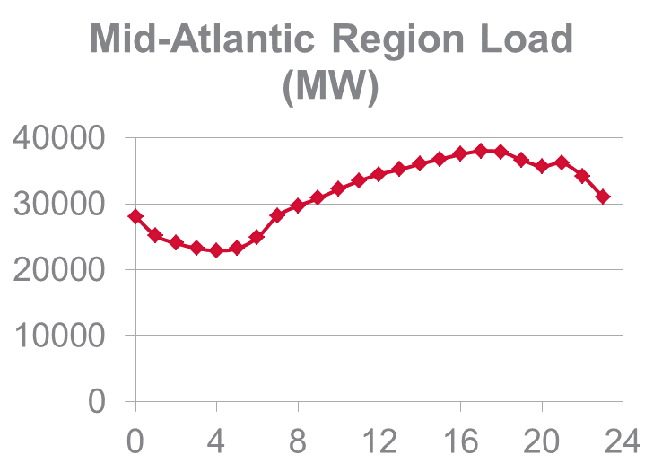

Rutgers CAES can determine the feasibility of a demand response program, or review the effectiveness of a current demand response program at your facility. In each case, options for reducing the plant's energy profile will be investigated and detailed in a report. Technical measures such as moving battery charging to night use, as well as production related measures such as moving a shift to the weekend and others will be considered. The demand response evaluation will also include an analysis of the current and predicted load profile resulting from implementing these measures.

Contact us for more information: [contact page](http://caes.rutgers.edu/contact)

## Building Energy Modeling

Rutgers CAES can construct a model of your building's energy usage.

* Predicted energy use from the model can be compared to actual energy use.
* The model can be used as a diagnostic tool to identify problem areas and savings opportunities

### (detail)

**Building Modeling**

Is your building consuming more or less energy than expected? This is a question that is difficult to answer without considering all the factors that affect energy use in a building, such as insulation, window type and placement, HVAC system type, etc. Building modeling can reveal many savings opportunities for your facility, in addition to giving you a gauge to measure your energy use against.

Rutgers CAES can construct an energy model of your facility using all of the building's relevant inputs. This model can show the expected consumption of your building, which can be compared against your facilities current consumption. This performance check can be used to determine if the HVAC equipment is aging and losing efficiency, if it was overdesigned to begin with or if manual overrides are present.

## Procurement Review

A review can be performed for multiple energy procurement options to determine the best fit for your plant:

* Rate structure review, rate negotiation and procurement hedging.
* Fuel switching and multi-fuel technology for risk diversification
* Onsite generation of nitrogen & oxygen feasibility.

### (Detail)

**Procurement Review**

Energy efficiency is only part of reducing energy costs; negotiating rate structures and other procurement measures can provide significant savings.

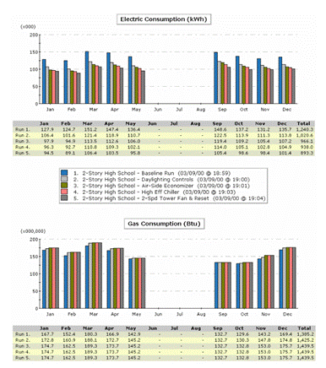

**Billing Structure and Energy Hedging**

Occasionally, plant energy usage changes to such an extent where the current rate structure they are on doesn't apply to them, which can add significantly to costs. Similarly, the contract lengths for procuring electricity, natural gas and other fuel sources can severely impact the energy costs at a plant. A long term contract can end up committing to higher costs if the price of fuel decreases, and conversely a short term contract can leave the company at the mercy of market fluctuations. The "One Third" rule can help to mitigate costs by spreading out the contract lengths. A split of 1/3 spot market, 1/3 one year contracts and 1/3 three year contracts can combine the benefits of each type while spreading out the risk. Rutgers CAES can provide a review of energy bills to determine the optimum rate structure, as well as provide a simple analysis of energy hedging strategies.

**Fuel Switching:**

Having multiple options for fuel sources minimizes the risk to a facility. For facilities that need oxygen or nitrogen in large quantities, onsite generation may cost significantly less than purchasing in bulk. Technologies that allow switch between fuels, such as multi-fuel boilers, allow a company to switch to the cheapest option seamlessly. Rutgers CAES can review the options available for fuel switching, a prepare a technical report detailing the annual savings and implementation costs a facility can expect from implementing a fuel switching or generation measure.

# IAC Student Training Demos

The use of simple instruments to help read and record physical aspects of an energy consuming system has expanded the way energy assessments are conducted. As simple as these instruments are, it is observed that most individuals that would benefit from knowing how to correctly use the equipment in fact do not, or how to interpret the data given from the instruments. This has given rise to the task of educating individuals who would benefit from learning the proper use of these tools.

While the best place to learn about best practices in terms of measurements is in the plant, many training programs take place in gentler environments – often a hotel conference room.  Presentations with pictures of measuring devices or holding up a pitot tube or thermocouple does not give the student the experience necessary to overcome worries that they are too complicated or difficult to use. To address this, in conjunction with the U. S. Department of Energy, The Center for Advanced Energy System from Rutgers University has developed five portable laboratories to train personnel on the use of monitoring and recording equipment. The labs utilize equipment frequently used by professionals in the field which include; thermocouples, flue gas analyzers, pressure transducers, ultra-sonic leak detectors, data loggers, light meters, current transducer and multi-meters. Lab demonstrations were designed to model energy consuming systems in industry as well as diagnose common problems using the instruments.

## VFD and Air Flow Lab

### Introduction

It is very common in a manufacturing setting to need to control the flow rate through ducts and pipes. Historically this has been done by installing valves or dampers inside the pipes. However, another method that has been more recently begun to be implemented is to vary the speed of the motor driving the fan or pump. This is accomplished using a variable frequency drive (VFD).

Using this method, the air flow rate can be decreased by reducing the motor’s power draw and, unlike the valve regulated duct, does not create a pressure buildup. Affinity laws can be used to examine the rate of energy consumption with varying volumetric flow rates. These laws allow for the theoretical prediction of several operational characteristic of a fan, such as pressure, flow rate, and power consumption. Considering a system with constant impeller diameter, the theoretical power consumption can be derived in terms of the ratio of flow rates. This control strategy makes use of the affinity law relating flow rate to power draw:



Where

W1         =             Power draw to achieve flow rate Q1

W2         =             Power draw to achieve flow rate Q2

Q2          =             flow rate at adjusted power draw W2

This relationship is illustrated in the following figure where volumetric flow rate is increased in increments up to the maximum flow rate of the fan (148 cfm) and the power consumption responds by increasing logarithmically and never actually reaches the power rating (100W).

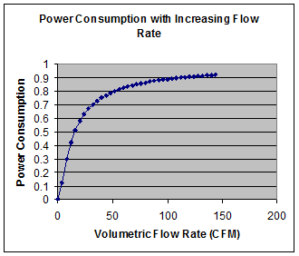

### Equipment

|  |  |
| --- | --- |
|  | Inverter/Variable-Frequency Drive (Hitachi L100)  The inverter takes AC power and converts it into DC current. The frequency is then adjusted accordingly before the device reconverts to AC current to power the motor. |
|  | 3-Phase Blower (Dayton 3HMJ4)  This is a standard air blower with a flow capacity of 148 CFM. An inverter must be connected for it to operate from standard 2-phase AC power; a brief introduction to 3-phase power is given in motor lab. |
|  | Anemometer (Omega HHF11A)  This sensor measures air flow velocity by means of a rotating fan, which produces an output on the attached device. For most accurate results, keep the sensor in the middle of the flow area. |
|  | Manometer (Dwyer Mark II 25)  This meter is used in conjunction with a pitot tube. The air flow detected from the pitot tube is translated into a velocity value from reading the manometer. |

### Additional Equipment

* Straight pipe with valve regulator
* Pitot tube
* HOBO datalogger with current reader (optional)

### Setup

Assemble the blower and the pipe together. The valve regulator should be near the blower end of the pipe. The other end should be free of obstructions to facilitate usage of the anemometer or the pitot tube. Connect the inverter to the extension cord, and connect the inverter to the blower. The final setup should appear similar to the below.

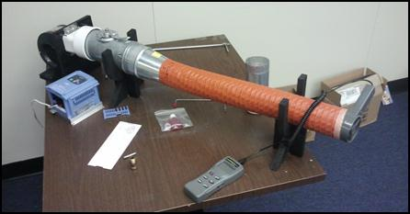

Fig. 1: completed blower setup

### Procedure

* Set up HOBO datalogger for CVC-A current sensor readings.
* Open the damper all the way ensuring the handle is as horizontal as possible.
* Turn the potentiometer on the inverter to the minimum position.
* Plug the inverter into the wall and press the run button. The LCD readout should read 0 Hz.
* Holding the damper in the horizontal position, slowly increase the speed of the blower by turning the knob on the inverter clockwise. Be sure to take readings using the anemometer at the speeds specified below.
* Once the maximum speed has been achieved (60hz) very slowly adjust the flow of the blower using the damper. Take measurements using the anemometer every 10 to 20 seconds until the damper is fully closed.
* Retrieve data from HOBO datalogger and plot in excel to correlate flow rate with power consumption.

|  |  |  |
| --- | --- | --- |
| Frequency (Hz) | Damper position | Speed of air (ft/min) |
| 10 | Fully open |  |
| 20 | Fully open |  |
| 30 | Fully open |  |
| 40 | Fully open |  |
| 50 | Fully open |  |
| 55 | Fully open |  |
| 60 | Fully open |  |
| 60 | Reducing |  |
|  |
|  |
|  |
|  |
|  |
|  |
| 60 | Fully closed |  |

### Discussion

VFDs are wonderful devices that can help save energy, but they have their limitations. In terms of energy savings, why is a VFD preferred over a damper or regulator? What are the physical constraints in using a VFD, and why is not a good idea for all applications in which controlling air/liquid flow rate is desired?

### Results

The following is a sample of the data collected by Rutgers CAES. Your data may or may not be different from the graph shown here, depending on the flow rate of the blower, and the minimum and maximum frequencies of the VFD in use.

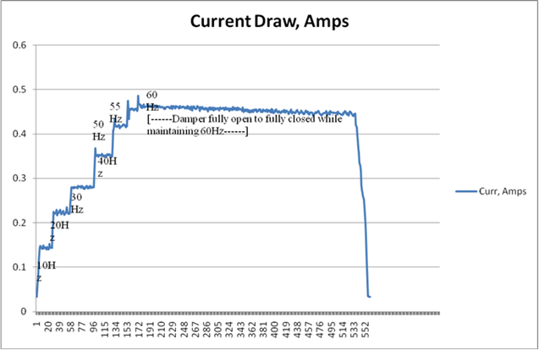

## Flue Gas Analysis Lab

### Introduction

In this lab you will learn to measure excess oxygen content in a flue produced from the combustion of exhaust gas using a handheld flue gas analyzer.  Oxygen content in a flue is used as an indicator of the overall air content in the combustion process. The most power or energy comes out of a combustion process with a lower air to fuel ratio (AFR), as shown in the chart below:

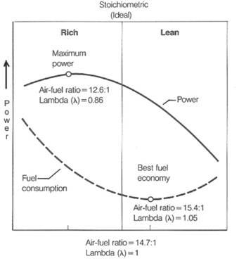

Having too much or too little air both contributes to lower efficiencies. Flue gas is analyzed to determine the efficiency of a combustion process. There must be enough oxygen in the system for combustion to happen, as combustion cannot occur without the presence of oxygen. At the same time, too much oxygen indicates an excess amount of air, which has the effect of lowering the overall temperature of the combustion process, again resulting in a loss of efficiency. In the case of this particular experiment, with propane as the fuel, the minimum theoretical oxygen level falls at around 2-4% of the combusted contents.

Nowadays, it is rare that this procedure will be necessary on an energy assessment, as environmental policies have required that the output of a facility’s flue gas match the codes set by law. However, proper background knowledge is essential to knowing how combustion affects the different processes that directly go into manufacturing.

### Definitions

Air to fuel ratio (AFR) is the mass ratio of air to fuel present in an internal combustion process. If exactly enough air is provided to completely burn all of the fuel, the ratio is known as the stoichiometric mixture. AFR is very important for efficiency measurement and performance-tuning of a combustion process.

The stoichiometric mixture is found by balancing the following equation dependant on the fuel used for combustion.

CnHm + X O2 → n CO2 + ½m H2O

Where X = ½(2n+½m)

In this particular experiment, propane is being used as the acting fuel, and it has a molecular formula of C3H8. The balanced stoichiometric equation for this formula comes out to be:

C3H8 + 5 O2 → 3 CO2 + 4 H2O

### Safety

We will be working with open flame and metal equipment subject to high temperatures, as such, it is highly recommended that the user be wearing protective thermal gloves. The exhausted air from the process will be high in carbon monoxide and carbon dioxide so be sure to avoid directly breathing in the fumes being exhausted from the flue. Make sure that this experiment is always conducted outdoors in a well ventilated open area.

### Equipment

|  |  |
| --- | --- |
|  | Flue Gas Analyzer (Bacharach Fryite Tech Analyzer)  The analyzer contains a simple pump that continually pulls in air through the tip of the probe, and displays a readout of percentage of oxygen in the general vicinity. |

### Additional Equipment

* Thermal Gloves
* Lighter
* Bunsen Burner
* Portable Tank of Propane (LPG)
* Vacuum Grease
* Combustion simulator (see below)

### Setup

The combustion simulator was constructed from scratch from parts found at the local hardware store. For reference, we have included a Solidworks drawing of the lower half of the apparatus.

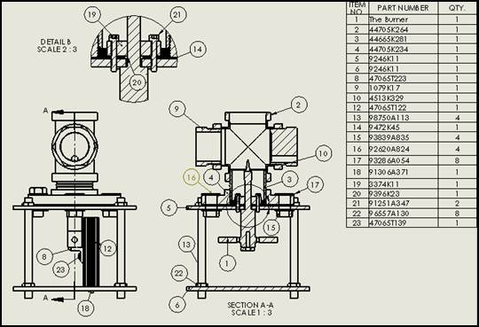

Fig. 1: Solidworks drawing of combustion simulator

The stack pipe itself can be made out of any material desired, as long as it retains heat, reduces turbulent air flow which could extinguish the flame, and has fittings for the probe of the flue gas analyzer. Our pipe also contains a small window on the side to view the flame and make sure it has not extinguished.

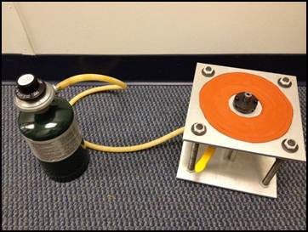

Fig. 2: lower half of the combustion simulator

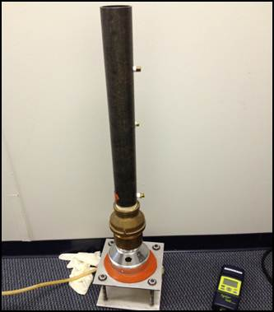

Fig. 3: Combustion simulator with stack pipe attached

### Procedure

* In a well-ventilated area, connect the LPG tank to the Bunsen burner as the fuel source.
* Make sure that the valve on the Bunsen burner is fully opened to allow for free flow
* Open the tank to full and light the burner.
* Place the Portable Flue Apparatus over the burner, ensuring that it is centered above the flame. It is recommended that the bottom of the flue be coated with a layer of a vacuum grease to properly seal the contact area of the bottom of the pipe and the silicone padding.
* Turn on the flue gas analyzer and set it to the proper fuel setting (in this case, LPG) allow it to purge of its contents and stabilize to about 20-21% Oxygen in ambient air.
* Position the metal insert of the flue gas analyzer in the center of the flue perpendicular to the flow, making sure it is completely sealed in so as to not allow for any extra air to mix in.
* Check and record the readings with the valve on the Bunsen burner at various positions including as fully open, at ¾ open, ½ open, and ¼ open making sure not to choke out oxygen enough to extinguish the flame.

### Discussion

Using the data from the analyzer, plot the graph for oxygen content versus carbon dioxide to determine an approximation for the AFR and the graph for the calculated AFR based on the molecular formula of the fuel.  What does the experimental error look like? What kind of trends do you see? Assuming that the flue apparatus didn’t have any leaks, did the values come out as expected?

## Compressed Air Demonstration Lab

### Introduction

Compressed air is one of the most common and misunderstood energy consumers in both industrial and commercial applications. It is used in many applications such as for power tools, pneumatics, and cleaning. In this lab you will learn about the setup of a standard compressed air system, and the problems commonly encountered by these systems. You will also learn about some of the different tools energy engineers have to perform analysis on compressed air equipment, including data loggers, pressure transducers, vibrations meters, and ultrasonic leak detectors.

### Equipment

|  |  |
| --- | --- |
|  | **Portable Air Compressor (Craftsman 125 psi Compressor)**  This is a simple and portable electric powered air compressor unit with a 3 gallon capacity and 125 psi maximum pressure. |
|  | **Ultrasonic Leak Detector (UE Systems UltraProbe 100)**  The leak detector picks up the ultrasonic frequency range emitted by air passing by the edges of a leak in the pipe. Headphones connected to the unit allow us to hear these sounds that would otherwise be out of human hearing range. |
|  | **Vibration Meter (Sper Scientific 840063)**  The magnet at the tip of the sensor sticks to metal surfaces of industrial equipment, allowing measurements to be taken of the vibrations of the system. |

### Additional Equipment

* Thermocouple
* Pressure transducer
* Data loggers

### Setup

Connect the thermocouple through the drain valve on the tank, and attach the pressure transducer to the quick-connect port. Run these measurement devices to the data loggers. Once the compressor is powered on, begin logging the data. Attach the vibration meter using the magnet to the casing of the compressor tank.

Procedure

* Turn on the compressor and let it run until it reaches maximum pressure and shuts off automatically.
* Shut off the compressor and let the air in the tank settle for a few minutes.
* Fully open the discharge valve until all no more air escapes from the tank.
* Disconnect the data loggers and upload the results to the computer.
* Recharge the tank and turn off the compressor.
* Put on the headphones connected to the ultrasonic leak detector. Scan the area around the quick-connect ports. Can you detect any escaping air?
* Take a reading of the vibrations of the compressor system on a flat hard surface. Now place the compressor onto a soft surface (foam packaging works well for this purpose). Take a reading again. Is there a noticeable difference?

### Discussion

Using the data from the loggers, plot the graphs for temperature and pressure as a function of time. What kind of trends do you see? From your knowledge of thermodynamics, you should expect dramatic temperature changes involved with compressed air. Assuming that the tank didn’t have any leaks, did the ultrasonic leak detector work as expected? Based on your measurements, is a soft or hard base better to curb vibrations in equipment?

## Motor Demonstration Lab

### Introduction

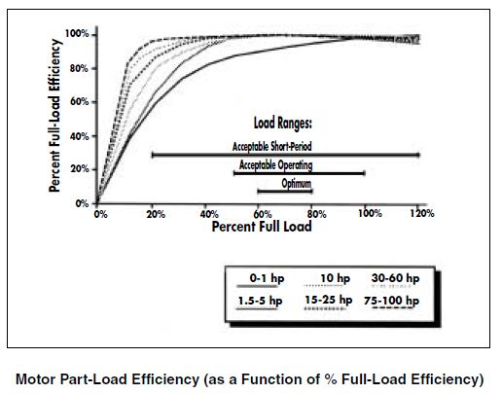

The purpose of this lab is for you to understand and measure power factor, motor efficiency, and load balancing using a 3-Phase motor. Most electric motors are designed to run at 50% to 100% of the rated load. Maximum efficiency usually occurs at 75% of the rated load, while efficiency tends to drop drastically below 50% load.

The motor in this lab will be connected to a 3-Phase power source. It will be in line with a torque sensor and hooked up to a generator in order to power a bank of 8 light bulbs, 6 300W 120V bulbs and 2 100W 120V bulbs. The bulbs will be turned on on at a time, in order to observe the load and strain on the motor and generator set up.

### Three Phase Power

In this lab, we will be using Three-Phase Circuits. Three conductors supply AC voltage, offset in time or phase, so that they peak not simultaneously but at equally spaced intervals. This produces constant smooth torque from a motor, because at all moments, the sum of power from all three phases is constant.

Power derived from a Single-Phase AC source peaks and falls to zero 120 times per second. This causes torque pulsations in motors, creating noise, vibration, and higher shaft stresses. Larger motors usually require Three-phase power, which avoids the problem.

There are two ways to measure Three-phase voltage—between two of the three lines or between a line and neutral or ground. Service and motor voltages are quoted as line to line, unless otherwise noted. Because of the phase difference, line-to-line readings are 1.73 times line-to-neutral readings.

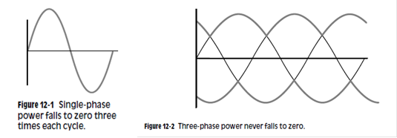

Inside a three-phase motor there are three windings, one for each phase. The easiest three-phase motor connection to visualize is with each of the three windings connected line to neutral. This is called wye because, schematically, it looks like the letter “Y”. A more common connection eliminates the neutral tie and connects the three windings from line to line. This is called delta because, schematically, this looks like a triangle or the Greek letter Delta. The winding experiences 73% higher voltage when connected line to line, so it must be designed for the type of connection it will have. Even if a motor’s windings are internally wye connected, its nameplate voltage rating is the line-to-line value.

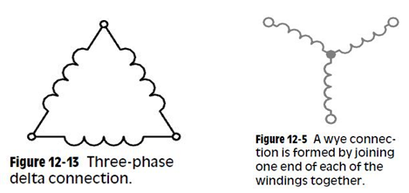

### Power Factor

Instantaneous power is proportional to instantaneous voltage multiplied by instantaneous current. AC voltage causes the current to flow in a sine wave replicating the voltage wave. However, inductance in the motor windings somewhat delays current flow, resulting in a phase shift. This transmits less net power than perfectly time matched voltage and current of the same Root Mean Square values. Power factor is the fraction of power actually delivered in relation to the power that would be delivered by the same voltage and current without the phase shift. Low power factor does not imply lost or wasted power, just excess current. The energy associated with the excess current is alternately stored in the windings’ magnetic field and regenerated back to the line with each AC cycle. This exchange is called reactive power.

Power Factor (PF) is the ratio of the active (true or real) power to the apparent power where:

* Active (Real or True) Power is measured in watts (W) and is the power drawn by the electrical resistance of a system doing useful work.
* Apparent Power is measured in volt-amperes (VA) and is the voltage on an AC system multiplied by all the current that flows in it. It is the vector sum of the active and the reactive power.
* Reactive Power is measured in volt-amperes reactive (VAR). Reactive Power is power stored in and discharged by inductive motors, transformers and solenoids



Where,

PF = power factor

P = active (true or real) power (Watts)

S = apparent power (VA, volts amps)

Power Factor - PF - as the cosine of the phase angle between voltage and current - or the "cosφ"

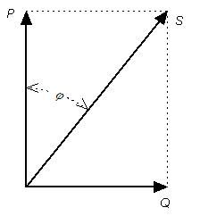

The total power required by an inductive device as a motor or similar consists of

* Active (true or real)  power (measured in kilowatts, kW)
* Reactive power - the nonworking power caused by the magnetizing current, required to operate the device (measured in kilovars, kVAR)

The power factor for a three-phase electric motor can be expressed as:



Where,

PF = power factor

P = power applied (W, watts)

U = voltage (V)

I = current (A, amps)

Load Factor

The ratio of the average load in kilowatts supplied during a designated period to the peak or maximum load in kilowatts occurring in that period. Load factor, in percent, also may be derived by multiplying the kilowatt-hours (kWh) in the period by 100 and dividing by the product of the maximum demand in kilowatts and the number of hours in the period.



Where,

Load = Output power as a % of rated power

Pi = Measured three-phase power in kW

Pir = Input power at full-rated load in kW



Where,

Pi = Three-phase power in kW

V = RMS voltage, mean line-to-line of 3 phases

I = RMS current, mean of 3 phases

PF = Power factor as a decimal



Where,

Pir = Input power at full-rated load in kW

hp = Nameplate rated horsepower

ηfl = Efficiency at full-rated load

### Efficiency

Most analyses of motor energy conservation savings assume that the existing motor is operating at its nameplate efficiency. This assumption is reasonable above the 50% load point as motor efficiencies generally peak at around 3/4 load with performance at 50% load almost identical to that at full load. Larger horsepower motors exhibit a relatively flat efficiency curve down to 25% of full load.

Three steps are used to estimate efficiency and load. First, use power, amperage, or slip measurements to identify the load imposed on the operating motor. Second, obtain a motor part-load efficiency value consistent with the approximated load from the manufacturer. Finally, if direct-read power measurements are available, derive a revised load estimate using both the power measurement at the motor terminals and the part-load efficiency.



Where,

η          =          Efficiency as operated in %

hp        =          Nameplate rated horsepower

Load    =          Output power as a % of rated power

Pi            =          Three-phase power in kW

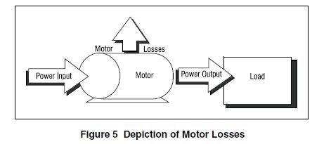

### SAFETY

We will be working with high voltages. Anyone plugging in the 3 phase motor or taking measurements on the AC Panel MUST wear the protective gloves.

Also, keep all your loose clothes, jewelry, hair, or anything else that extends from your body (i.e. hands) away from the motor. There are spinning parts that could grab your loose belongings and hurt you.

Equipment

* AC Panel
* 3 Phase AC Motor
* Tachometer
* 1 Phase AC Generator
* Bank of Light Bulbs
* Ammeter
* Protective Gloves
* Data Logger

### Data

Our motor is rated at 5 HP

1 HP = 0.746 kW

Total Power of a 3φ System =  power from black line *

### Diagram of Set up

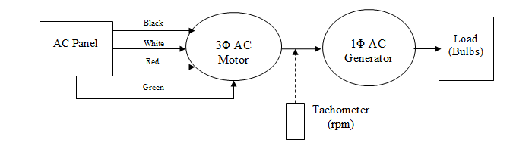

### Pictures of Set up

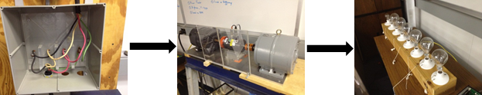

[AC Panel](https://caes.rutgers.edu/images/labs/IMG_0883.JPG) ----------->[Motor Assembly Overview](https://caes.rutgers.edu/images/labs/IMG_0884.JPG)--->[Torque Meter](https://caes.rutgers.edu/images/labs/IMG_0886.JPG)---> [Generator](https://caes.rutgers.edu/images/labs/IMG_0887.JPG)--->[Light Bulb Array](https://caes.rutgers.edu/images/labs/IMG_0888.JPG)

### Procedure

* Assign one of the following tasks to each group member: data logger, AC Panel data taker, a tachometer user, someone to turn the light bulbs on.
* Connect power factor instrument to the black phase. Make sure the ammeter is enclosing only one line and make sure it is closed all the way. Turn the power factor meter onto “PF” mode.
* With the gloves on, plug in the motor.
* With the gloves on, read and record amps and power factor for the black line. Measure and record the volts from black line to white line or red line.
* With the tachometer, measure the RPM of the shaft.
* Measure the torque output of the motor as measured by the Torque Sensor. The measurement is displayed on the digital strain gage indicator.
* Turn on one light bulb.
* Repeat steps 4 to 7 until all 8 bulbs are on. Turn the light bulbs on in order.
* Observe the torque output as each bulb is turned on and off.

### Discussion

Discuss what happens to various components of the motor setup demo when an additional light bulb is turned on or off. After going through and turning all 8 bulbs on one at a time and recording the data for each additional bulb, try different combinations of 300W and 100W bulbs. Talk about the relationships between Load Factor and RPMs as well as Power Factor and Load Factor. Plot the results of these relationships on graphs.

Results

Example Plot of Load Factor vs RPM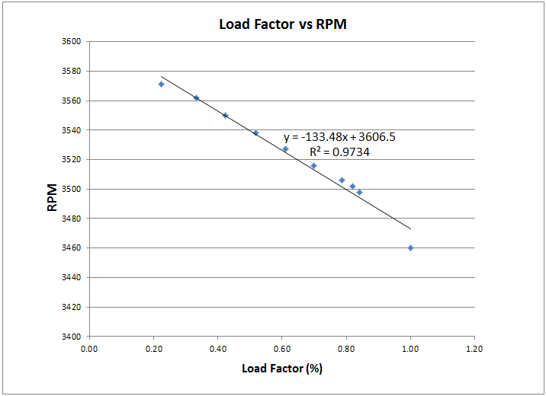

Example Plot of Power Factor vs Load Factor

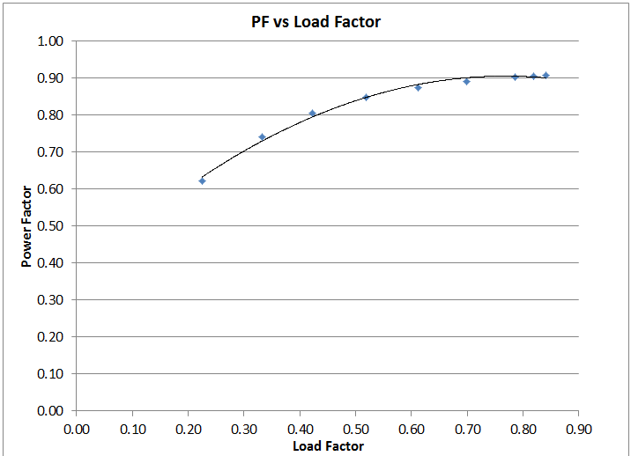

## Office Environment Lab

### Introduction

When on an assessment, it is important to keep an eye out for ways to save energy not just in the manufacturing process, but also in the standard and common things such as lighting. In this lab, you will learn about the different tools energy engineers have at their disposal to identify potential energy savings in the office space and other similar environments.

### Equipment

|  |  |
| --- | --- |
|  | Laser Distance Measure (Johnson 40-6001)  The distance measure here can either measure the distance to an object directly, or perform trigonometry by measuring two other points before calculating distance. |
|  | Infrared Thermometer (Westward 1VER4)  An IR gun is an easy, fast, and relatively accurate way of determining temperature at the surface of an object. Point the laser at the surface to be measured, and pull the trigger. After a few seconds, the temperature should appear on the display. |
|  | CO2 Detector (Telaire 7001)  This device measures the concentration of carbon dioxide in the air in PPM (parts per million). Hold the detector in an area undisturbed for a few minutes until you obtain a constant reading. |
|  | Phantom Load Meter (Kill-A-Watt)  The Kill-A-Watt meter is able to measure the amount of current flowing through an electrical device even when it is apparently turned off. Plug the device to be measured into the meter, and plug the meter into the wall to display the current. |
|  | Light Meter (EZTECH HD450/401036)  The actual sensor is the black object with the bulb in the picture. When held up to a light source, the sensor will send the measured lumen reading to the digital multimeter. |
|  | Draft Detector (Wizard Stick)  Any smoke/fog generator works for this purpose. By producing a plume of smoke near a window or other location with possible ventilation issues, the direction and speed at which the smoke travels will reveal the airflow patterns. |

### Setup

Find a room with sufficient area to safely perform experiments. No additional preparation is required for this lab.

### Procedure

Distance is a very important factor in assessing the necessity of certain energy efficient upgrades. For instance, in the case of dealing with stratification, the number of fans to be installed will depend on how far apart they are and how big the room is. The laser distance measure is an extremely convenient tool to use in such applications.

* Turn the laser measure on and aim the laser at an object. Be sure to check the bubble level to make sure you are measuring parallel to the floor or wall.
* Take measurements of the room, preferably one which you already know the dimensions (or can check with an alternate method). How accurate is the laser measure?

During the heating season, it is not uncommon for a significant temperature stratification to develop in areas with high ceilings. As warm air is naturally lighter than colder air, it will tend to rise; this results in the cold air getting pooled at floor –level and the warm air pooling at a level that is too high to provide any comfort which increases energy consumption. To combat this issue, de-stratification fans can be used to keep the air in a room well mixed.

* Point the IR gun at different objects in the room and record the temperature from the display. To obtain an accurate reading, the trigger should be held down for 5-10 seconds.
* Take a temperature reading of the ceiling, and then another of the floor. Compare the temperatures. Do you see a difference?

A CO2 measurement device measures the concentration of carbon dioxide in the air, which is a useful indicator of whether or not there is a sufficient air exchange rate for the number of people in a space or if the rate greatly exceeds the necessary rate. The American Society of Heating, Refrigeration and Air-Conditioning Engineering (ASHRAE) states that carbon dioxide levels should not 1000 ppm, and that an appropriate ventilation rate for office buildings is 20 CFM/person. High levels of CO2 could pose serious indoor air quality issues, while over ventilating significantly increases energy bills since HVAC systems must work harder than needed.

* Obtain CO2 readings at different locations in the room. It is important to remain in each location for a few minutes until a constant reading is obtained.
* Try taking a reading in locations with a varying amount of people, if possible. Does the level of CO2 fluctuate according to how populated the room is?

A phantom (ghost) load measurement device provides numerous electrical measurements, the most important one being electrical consumption in watts. Most devices consume electricity even when we think they are powered off. The US Department of Energy states that in the average home, 75% of the electricity used to power home electronics and appliances is consumed while the products are turned off.

1. Use the Kill-A-Watt meter on equipment around the office, such as computers, printers, microwaves, etc. Can you estimate how much current is being drawn by these devices?
2. Quantify these values into potential savings.

The recommended level of lighting varies for different applications, with 500 lux (lumens/m2) being an appropriate level of illumination for normal office work. For safety reasons, the illumination in a room should not fall below the recommended level; illumination standards are available from the Illumination Engineers Society (IES). Illumination exceeding the recommended lighting level means that a building is using more energy for lighting than is needed and, so an energy savings opportunity exists. A lumen meter can help determine if a workspace is being excessively illuminated.

1. Hold the light meter at different heights and angles near different light sources in the room. Record the corresponding read-out values.

Pressure differences between adjacent rooms cause drafts which are both uncomfortable and energy consuming. It is expensive for conditioned air from one room to be sucked away into another space (i.e. outside, hallways). This can sometimes be caused by an unbalanced ventilation system, an uneven distribution of conditioned air in the building, and, thus, an increased load on the HVAC system. A useful way to detect these pressure differences is by using draft detectors. These devices emit some kind of smoke or mist that helps to visualize the direction of airflow. Once the source of the problem is determined, significant savings can be realized by readjusting the HVAC system.

1. Light the smoke stick and if it is electronically generated, wait for a sufficient amount of smoke to generate.
2. Use the stick near doors, windows, and hallways. Are there any observable patterns or trends in airflow?

### Discussion

Discuss possible recommendations that you could make for a facility based on the results given by these tools. Explain problems such as stratification, phantom power loss, and negative pressure. What solutions are available for manufacturers to implement in their facilities?

# Directions to CAES

### From New Jersey Turnpike (North or South):

Turn off at Exit 9. After tollbooths stay to the right and follow signs for "Route 18 North-New Brunswick." Continue along Route 18 North past the exits for "Route 27" and Rutgers University and proceed over the Raritan River on the John Lynch Memorial Bridge (Approx. 3.7 miles). On the other side of the river, take the second exit on the right hand side for Busch Campus. Proceed straight to the stop sign at the circle, and make the first immediate right, Bartholomew Road. At first stop sign, turn left onto Brett Road. Follow Brett Road to the end and at stop sign enter parking lot (Lot # 64). Follow cement walk in the near left corner of the parking lot to the Winlab modular building labeled the Center for Advanced Energy Systems.

### From Garden State Parkway (North or South)

*Southbound - coming from northern New Jersey*

Take Exit 129 for the New Jersey Turnpike and head south. Follow directions to campus from the New Jersey Turnpike (see above)

*Northbound - coming from southern New Jersey*

Take Exit 105 and follow signs for Route 18 North After approximately 24 miles you will pass the entrance for the New Jersey Turnpike and continue on Route 18 North Follow directions to campus from the New Jersey Turnpike

### **From Route 1** (North or South):

Turn off at exit marked Route 18 North - New Brunswick. Continue along Route 18N past the exit for "Route 27 and Rutgers University" and proceed over the Raritan River on the John Lynch Memorial Bridge (approx. 3.7 miles). On the other side of the river, take the second exit on the right hand side for Busch Campus. Proceed straight to the stop sign at the circle, and make the first immediate right, Bartholomew Road. At first stop sign, turn left onto Brett Road. Follow Brett Road to the end and at stop sign enter parking lot (Lot # 64). Follow cement walk in the near left corner of the parking lot to the Winlab modular building labeled the Center for Advanced Energy Systems.

### **From Route 287** (North or South):

Turn off at Exit 9 (formerly Exit 5) "River Road, Bound Brook, Highland Park." Proceed East on River Road toward Highland Park until you reach the sixth traffic light (approximately 3.4 miles) at the intersection of River Road, Metlars Lane and Route 18. Turn left at the River Road traffic light onto Metlars Lane (stay in right lane). Take first right exit, labeled Busch Campus. Proceed straight to the stop sign at the circle, and make the first immediate right, Bartholomew Road. At first stop sign, turn left onto Brett Road. Follow Brett Road to the end and at stop sign enter parking lot (Lot # 64). Follow cement walk in the near left corner of the parking lot to the Winlab modular building labeled the Center for Advanced Energy Systems.

# Media & News

*Center Mailing Address:*

Center for Advanced Energy Systems

Rutgers, The State University of New Jersey

73 Brett Road

Piscataway, NJ 08854

**Phone:** 732.445.5540

**Fax:** 732.445.0730